I am pleased to announce the JK Performance Coaching Australian Golf Foundation Junior Girls Golf Scholarship program.

JK Performance Coaching's mission is to provide girls between the age of 10 to 16 with the opportunity to start or continue their golfing journey with a group of girls a similar age.

The scholarship will provide a year’s membership and four school terms of tuition at JK Performance Coaching throughout 2021.

We invite any girl who may be interested in a golf scholarship to apply. Group tuition will run from 3/02/2022 for 24 sessions.

Further details of the scholarship program are attached.

Applications close on 07/01/2022.

Please do not hesitate to contact me for further scholarship information on 0438 357 890.

Kind regards

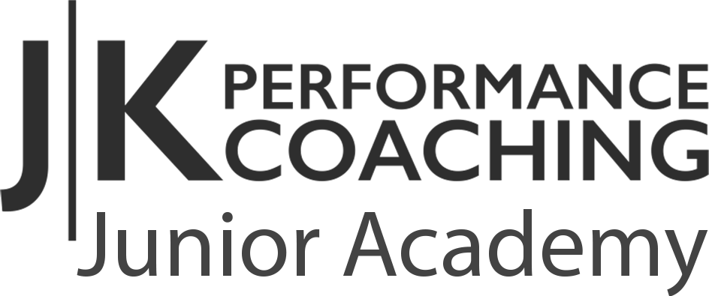
Jake Killeen

KEY INFORMATION FOR APPLICANTS

Why a scholarship program?

JK Performance Coaching is one of just 25 facilities across Australia to obtain funding from The Australian Golf Foundation (AGF), in association with Golf Australia. This funding has been made available because of the foresight and generosity of Bonnie Boezeman AO, a director of The Australian Golf Foundation.

While the program’s primary aim is to retain girls in golf by giving girls a shared golf experience, girls new to golf may also be engaged in this program should they demonstrate a commitment to learning the sport.

Who is the scholarship for?

The suggested ages for the program are girls from 10 to 16 years old. There are exceptions allowed for girls from 7 to 10 if they have already displayed exceptional capabilities for their age.

What does the program involve?

- A one-year junior club membership that carries playing rights, to ensure girls can participate in club competitions and obtain a handicap
- 24 sessions with the club professional and/or community instructor
- A club shirt and hat with AGF Scholarship identification

What commitments will scholarship holders be required to make?

- Display a desire and willingness to improve their golf skills, obtain a handicap, play in club competitions (or/and social play) and engage in any extra-curricular activities that fosters friendships between scholarship holders.
- As this is the program’s inaugural year, all scholarship holders will be required to complete a pre- and post-program evaluation survey. Scholarship holder contact details will therefore be supplied to Golf Australia upon successful application.
- Whilst we ask girls to strive and make the most out of the program, their commitment to the scholarship program will not, at any point of time take precedence over any education/school commitments.

Scholarship Term

Scholarships will be valid for one year only (2021), extensions will be subject to JK Performance’s scholarship committee.

Interested girls need to complete the following form and submit to JK Performance Coaching by 07/01/2022.

Please note, girls may be required to do an interview.

Basic Details
Full name
Date of Birth
Address
Nominated phone
Nominated email
Level of golf experience
School
Parent/guardian name
About me
Why do you want to be involved in the Scholarship Program? What are your goals for the program and golf in general?
What are your personal goals (For example, in school, when you grow up, general life goals)

